Def: Kubernetes is a platform that automatically runs, scales, and heals your containerized applications.
Version 1.33
Kubernetes is an open source container orchestration tool developed by google to help you manage the containerised / dockerized application supporting multiple deployment environments like on premise, cloud, or virtual machines.
What are the main features of K8s offers?
Assures high availability with zero down time
High performance and scalable
Reliable infrastructure to support data recovery
Disadvantages: it is very complex or takes lot of time for setting up the k8s infra
----------------------------------------------------------------------------------------------------
Docker swarm: I have not used docker swarm, but I have idea on this, and I use k8(Kubernetes) for container deployment.
It is a container orchestration tool, meaning that it allows user to manage multiple containers deployed across multiple host machine.
One of the key benefits associated with the operation of a docker swarm is the high level of availability offered for application.

Advantages of k8’s:
High Performance and Scalability
Reliable infrastructure to support data recovery
High availability with zero downtime

Disadvantages of k8’s:
Its very hard to setup
Its little complex
Setup the infrastructure from scratch

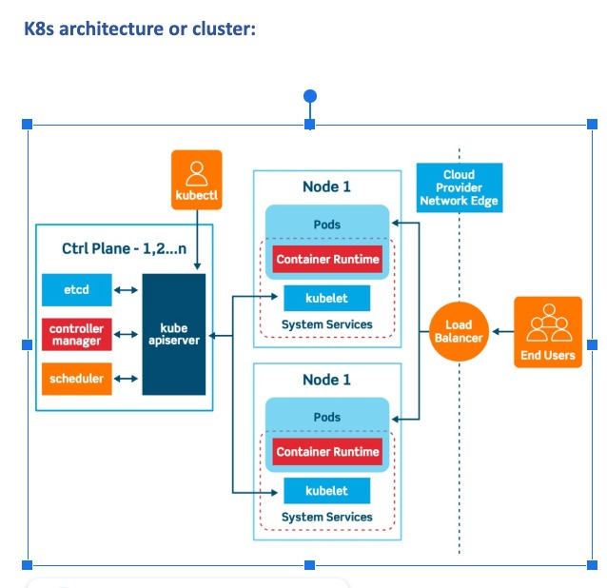
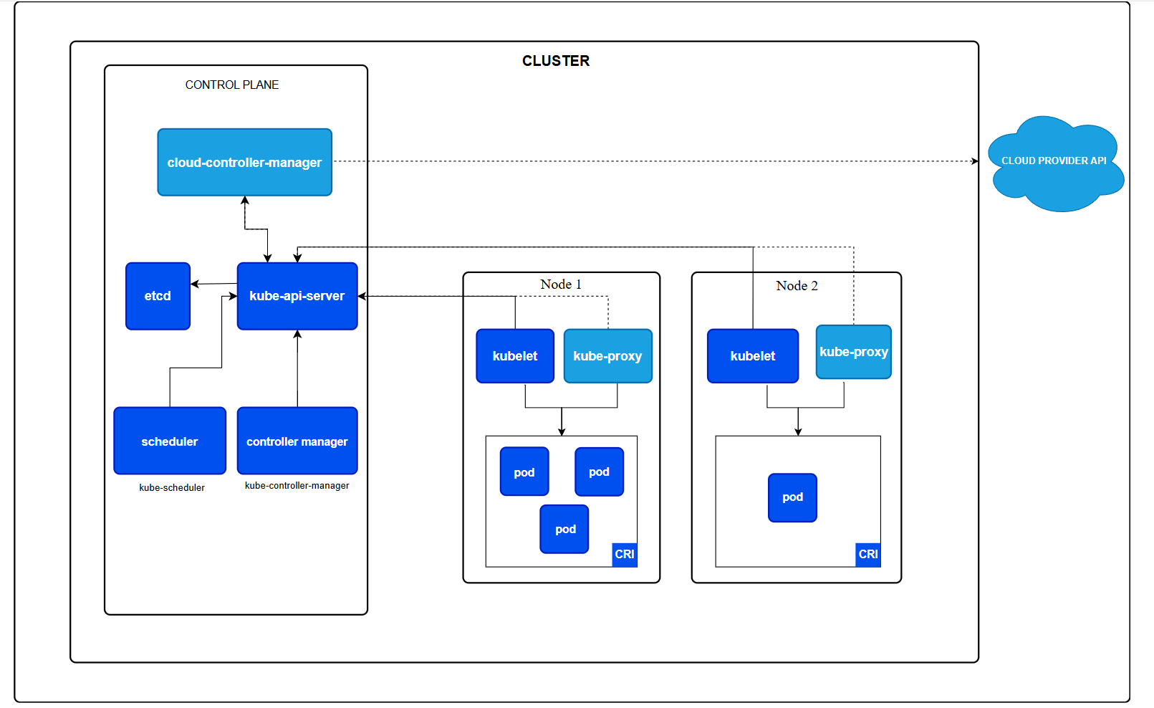

K8s cluster has two major components
Master node
Worker node
Node: physical machine or virtual worker machine where containers will be deployed by k8s.
Cluster: set of nodes grouped together.
Master or control plane manages the cluster
Components of K8s:
API server, scheduler, control manager etcd, kubelet, container runtime and kube-proxy.
Kubernetes Basics
we will learn some important Basics of Kubernetes:
Cluster:
It is a collection of hosts(servers) that helps you to aggregate their available resources. That includes ram, CPU, disk, and their devices into a usable pool.

Master:
The master is a collection of components which make up the control panel of Kubernetes. These components are used for all cluster decisions. It includes both scheduling and responding to cluster events.
Node:
It is a single host which is capable of running on a physical or virtual machine. A node should run both kube-proxy, minikube, and kubelet which are considered as a part of the cluster.
Namespace:
It is a logical cluster or environment. It is a widely used method which is used for scoping access or dividing a cluster.
Kubernetes Architecture:
Kubernetes has two nodes – master node and worker/slave node.
Master node:
The master node is the first and most vital component which is responsible for the management of Kubernetes cluster. it is the entry point of all kind of administrative tasks. there might be more than one master node in the cluster to check for fault tolerance.
The master node has various components like API server, Controller manager, kubectl, scheduler and ETCD.
ETCD:
This component stores the configuration details and essential values in key value form
{
“name”: “xyz”,
“part”: “ght”
}
It communicates with all other components to receive the commands to perform an action.
It is also called as meta data storage.

Controller Manager:
A daemon (server) that runs in continuous loop and is responsible for gathering information and sending it to the API server.
Works to get the shared set of clusters and change them to the desired state of the server.
The key controllers are the replication controllers, endpoint controllers, namespace controllers and service account controllers.
The controller manager runs controllers to administer nodes and endpoints.

Scheduler
The Schedular assigns the tasks to the slave nodes.
It is responsible for distributing the workload and stores resource usage information on every node.

API Server
Kubernetes uses the API server to perform all operations on the cluster.
It is central management entity that receives all REST requests for modifications, serving as frontend to the cluster.
Kubectl
Kubectl controls the Kubernetes cluster manager.

kube-controller-manager
Control plane component that runs controller processes.

Logically, each controller is a separate process, but to reduce complexity, they are all compiled into a single binary and run in a single process.

There are many different types of controllers. Some examples of them are:

Node controller: Responsible for noticing and responding when nodes go down.
Job controller: Watches for Job objects that represent one-off tasks, then creates Pods to run those tasks to completion.
EndpointSlice controller: Populates EndpointSlice objects (to provide a link between Services and Pods).
ServiceAccount controller: Create default ServiceAccounts for new namespaces.
The above is not an exhaustive list.

Node components
Node components run on every node, maintaining running pods and providing the Kubernetes runtime environment.

Worker/Slave nodes
Worker nodes are another essential component which contains all the required services to manage the networking between the containers, communicate with the master node, which allows you to assign resources to the scheduled containers.
Kubelet: gets the configuration of a Pod from the API server and ensures that the described containers are up and running.
Kube-proxy: Kube-proxy acts as a load balancer and network proxy to perform service on a single worker node.
Pods: A pod is a combination of single or multiple containers that logically runs together on nodes.

Container runtime
A fundamental component that empowers Kubernetes to run containers effectively. It is responsible for managing the execution and lifecycle of containers within the Kubernetes environment.

24-02-2026
Namespaces:
Namespace helps in creating a virtual cluster inside your Kubernetes cluster
Namespace helps you isolate your resources between different teams. Allocate resources or apply quota of resources

Advantages of namespace:
Helps in easy management of applications of each environment
Control multiple app with single name in a single cluster
Cost effective

Default k8s namespaces are.
Default: adding an object to a cluster without providing a namespace will place it within the default namespace
Kube-system: kube system namespace is used for k8s components managed by k8s
Kube-public: kube public it is readable by everyone, but the namespace is reserved for system usage
---------------------------------------27-02-2026--------------------------------------------------------
Pods:
Pods are smallest objects which can be created in Kubernetes cluster.
In terms of docker concepts, a pod is similar to a group of docker containers with shared namespace and shared file system volumes.
YAML (yet another mark-up language) File: YAML is a human readable data serialization language. It is commonly used for configuration files and in applications where data is being stored or
Kubectl create -f filename

Life cycle of k8s:
pending: if the container is not neither in running or terminated state it is pending.
Running: the running status indicates the container is running without issues
Terminated: the container in the terminated began execution and then either run to completion or fail for some reason.

Publishing service:
K8s service type allows you to specify what kind of service you want, the default is cluster IP
Type values and their behaviours are:
Cluste rIP: Exposes the service on a cluster internal IP. Using this value makes the service only reachable from within the cluster. This is the default service type.
NodePort: exposes the service on each nodes IP at a static port.
A cluster IP service, to which the nodes port service routes are automatically created.
LoadBalancer: exposes the service externally using a cloud providers load balancer.
Node port and cluster IP services, to which the external load balancer routes or automatically created.
ExternalName/ExternalIP: maps the service to the content of external fields by written a C name records within a value.

ReplicaSet:
A replicaset is a set of pod templates that describes a set of pod replicas. It uses a template that describes what each pod must contain.
The replicaset ensures that a specified number of pod replicas are running at any time.
We want to replicate containers (and thereby applications) for several reasons, including:
#1 - Reliability: By having multiple versions of an application, you prevent problems if one or more fails. This is particularly true if the system replaces any containers that fail.
#2 - Load balancing: Having multiple versions of a container enables you to easily send traffic to different instances to prevent overloading of a single instance or node. This is something that Kubernetes does out of the box, making it extremely convenient.
#3 - Scaling: When load does become too much for the number of existing instances, Kubernetes enables you to
easily scale up your application, adding additional instances as needed.
However, a Deployment is a higher-level concept that manages ReplicaSets and provides declarative updates to
Pods along with a lot of other useful features.
Therefore, its recommended using Deployments instead of directly using ReplicaSets, unless you require custom update orchestration or don’t require updates at all.
Deployment:
A deployment is an object in Kubernetes that lets you manage a set of identical pods. Without a deployment, you’d need to create, update, and delete a bunch of pods manually.
With a deployment, you declare a single object in a YAML file.
This object is responsible for creating the pods, making sure they stay up to date, and ensuring there are enough of them running.
Rollingupdate:
Kubernetes deployments rollout pod version updates with a rolling update strategy.
This strategy aims to prevent application downtime by keeping atleast some instance up and running at any point intime while performing the updates.
Old pods are only shutdown after new pods of the new deployment version have started up and became ready to handle the traffic.
MaxSurge: it indicates maximum number of pods need to be created before terminating the old pods.
maxUnavailable: this indicates number of unavailable pods during rolling updates

# kubectl taint nodes <nodename> key=value:taint-effect
where:
nodename name of the node
key=value some key value pair
taint-effect NoSchedule or PreferNoSchedule or NoExecute
#kubectl taint nodes node1.example.com \
color=pink:NoSchedule

Taint and toleration: these are work together to ensure that pods are not scheduled onto inappropriate nodes.
One or more taints are applied to a node, this marks that the node should not accept any pods that do not tolerate the taints.
Tolerations are applied to pods and allow the pods to schedule onto nodes with matching taints.

Taint and toleration are only meant to restrict the nodes to accept certain pods.
Taint and toleration don’t tell a pod to go to a particular node, instead it tell the node to accept pods with certain tolerations.
kubectl taint nodes node1 key1=value1:NoSchedule
Node Selector:
NodeSelector is the simplest recommended form of node selection constraint.

NodeSelector is a field of PodSpec. It specifies a map of key-value pairs. For the pod to be eligible to run on a node, the node must have each of the indicated key-value pairs as labels (it can have additional labels as well).
Step #1 - First label the node using kubectl command
#kubectl label nodes = #kubectl label nodes node2.example.com size=large
Step #2: Now create a pod definition, specifying the node selector for the pod.
There are limitations. You cannot use the condition that "place the pod on node either "large" or
"medium" but not "small".
You cannot use multiple checks. For that we use "affinity" and "anti-affinity"
Node Affinity (Advanced & Flexible)
Node affinity is more expressive and flexible than nodeSelector.
There are two types:
A) requiredDuringSchedulingIgnoredDuringExecution
👉 Hard rule (like nodeSelector)
Pod MUST match
If not → Pod stays Pending
Example:
spec:
affinity:
nodeAffinity:
requiredDuringSchedulingIgnoredDuringExecution:
nodeSelectorTerms:
- matchExpressions:
- key: disktype
operator: In
values:
- ssd
B) preferredDuringSchedulingIgnoredDuringExecution
👉 Soft rule
Scheduler tries to match
But can ignore if needed
Example:
spec:
affinity:
nodeAffinity:
preferredDuringSchedulingIgnoredDuringExecution:
- weight: 1
preference:
matchExpressions:
- key: disktype
operator: In
values:
- ssd
Pod Affinity in Kubernetes
Pod affinity controls which Pods should be scheduled together (or apart) based on labels of other Pods.
👉 Unlike nodeSelector/nodeAffinity (which use node labels),
pod affinity uses pod labels.
1️⃣ Why Use Pod Affinity?
You use it when you want:
Pods of the same app on the same node
Pods near each other (same zone / same rack)
Reduce latency between services
Improve data locality
2️⃣ Types of Pod Affinity
There are two main types:
✅ A) Pod Affinity (attract pods together)
Hard Rule
requiredDuringSchedulingIgnoredDuringExecution
Pod must be scheduled near matching pods
If no match → Pod stays Pending
Soft Rule
preferredDuringSchedulingIgnoredDuringExecution
Scheduler tries to place together
But can ignore if needed
🔹 Example: Hard Pod Affinity
This example says:
"Schedule this pod on a node that already has pods labeled app=backend in the same zone."
apiVersion: v1
kind: Pod
metadata:
name: frontend
spec:
affinity:
podAffinity:
requiredDuringSchedulingIgnoredDuringExecution:
- labelSelector:
matchExpressions:
- key: app
operator: In
values:
- backend
topologyKey: topology.kubernetes.io/zone
containers:
- name: nginx
image: nginx
🔎 Important Field: topologyKey
This defines how close the pods must be.
Common values:
topologyKey Meaning
kubernetes.io/hostname Same node
topology.kubernetes.io/zone Same zone
topology.kubernetes.io/region Same region
So:
hostname → same node
zone → same availability zone
region → same region
3️⃣ Pod Anti-Affinity (Spread Pods Apart)
This is the opposite.
Used for:
High availability
Avoid single point of failure
Spread replicas across nodes
Example:
affinity:
podAntiAffinity:
requiredDuringSchedulingIgnoredDuringExecution:
- labelSelector:
matchLabels:
app: frontend
topologyKey: kubernetes.io/hostname

Meaning:

"Do NOT place this pod on a node that already has another app=frontend pod."

🧠 Summary
Feature Pod Affinity Pod Anti-Affinity
Purpose Place pods together Keep pods apart
Based on Pod labels Pod labels
Hard rule Yes Yes
Soft rule Yes Yes
Uses topologyKey Yes Yes
🚀 Real-World Examples
Microservices that talk frequently → Affinity
Replica sets for HA → Anti-Affinity
Database + cache together → Affinity
Web replicas on different nodes → Anti-Affinity
Q: How would you design HA and workload isolation in Kubernetes?"
Ans: I would use taints to isolate critical nodes, node affinity to enforce placement, pod anti-affinity to ensure replica spreading, and pod affinity to optimize service locality."

03-03-2026
hostPath Types
You can control behavior using type:
Type Meaning
Directory Must exist
DirectoryOrCreate Create if not exists
File Must exist
FileOrCreate Create if not exists
Socket Unix socket
CharDevice Character device
BlockDevice Block device

When to Use Bind Mount (hostPath)
✅ Development
✅ Single-node clusters (like Minikube)
✅ Accessing node logs
✅ System-level agents
❌ Not recommended for production multi-node clusters
❌ Not portable
❌ Pod may fail if scheduled on another node

Why hostPath Is Risky
Pod depends on specific node
Breaks cluster portability
Security risk (container can access host filesystem)
For production, use:
PersistentVolume + PVC
Network storage (NFS, cloud disks, CSI drivers)
helm install aws-cloud-controller-manager aws-cloud-controller-manager/aws-cloud-controller-manager \
--namespace kube-system \
--create-namespace \
--values aws-ccm-values.yaml

helm status aws-cloud-controller-manager -n kube-system
2️⃣ Install the EBS CSI Driver via Helm
helm repo add aws-ebs-csi-driver https://kubernetes-sigs.github.io/aws-ebs-csi-driver
helm repo update
helm install aws-ebs-csi-driver aws-ebs-csi-driver/aws-ebs-csi-driver \
-n kube-system \
--create-namespace
1️⃣ Create ebs-sc.yaml
apiVersion: storage.k8s.io/v1
kind: StorageClass
metadata:
name: ebs-sc
provisioner: ebs.csi.aws.com
volumeBindingMode: WaitForFirstConsumer
reclaimPolicy: Delete
parameters:
type: gp3 # or gp2 / io1 / io2
fsType: ext4
encrypted: "true"
Create a PVC (PersistentVolumeClaim)
apiVersion: v1
kind: PersistentVolumeClaim
metadata:
name: ebs-test-pvc
spec:
storageClassName: ebs-sc
accessModes:
- ReadWriteOnce
resources:
requests:
storage: 1Gi

Apply it:
kubectl apply -f ebs-test-pvc.yaml
kubectl get pvc
Once the PVC is Bound, you can mount it in a pod:
apiVersion: v1
kind: Pod
metadata:
name: ebs-test-pod
spec:
containers:
- name: app
image: nginx
volumeMounts:
- name: ebs-vol
mountPath: /usr/share/nginx/html
volumes:
- name: ebs-vol
persistentVolumeClaim:
claimName: ebs-test-pvc

Key Differences from Other Storage
Feature Object Block File
Structure Objects Raw blocks Files & folders
Hierarchy Flat (key-based) No Yes
Scaling Massive Limited Moderate
Good for Backups, media Databases Shared drives

13-Mar-2026

Kubernetes RBAC (Role-Based Access Control)
Kubernetes RBAC is the built-in authorization system that controls who can do what on which resources in a Kubernetes cluster. It lets you assign permissions to users, groups, or service accounts using roles.
RBAC answers three questions:
Who is making the request? (User / Group / ServiceAccount)
What action are they trying to perform? (get, list, create, delete, etc.)
On which resource? (pods, deployments, services, etc.)

Role
A Role defines permissions within a specific namespace.
Example: Allow reading pods in a namespace.
apiVersion: rbac.authorization.k8s.io/v1
kind: Role
metadata:
namespace: dev
name: pod-reader
rules:
- apiGroups: [""]
resources: ["pods"]
verbs: ["get", "watch", "list"]
Explanation
resources: Kubernetes objects (pods)
verbs: actions allowed
namespace: scope where it applies

ClusterRole
A ClusterRole defines permissions cluster-wide.
Used for:
nodes
persistent volumes
cluster-level access
Example:
apiVersion: rbac.authorization.k8s.io/v1
kind: ClusterRole
metadata:
name: pod-reader
rules:
- apiGroups: [""]
resources: ["pods"]
verbs: ["get", "list", "watch"]
ClusterRoles can also be used inside namespaces.

RoleBinding
A RoleBinding assigns a Role to a user, group, or service account in a namespace.
Example:
apiVersion: rbac.authorization.k8s.io/v1
kind: RoleBinding
metadata:
name: read-pods
namespace: dev
subjects:
- kind: User
name: jane
apiGroup: rbac.authorization.k8s.io
roleRef:
kind: Role
name: pod-reader
apiGroup: rbac.authorization.k8s.io
Meaning:
User jane can read pods in dev namespace

ClusterRoleBinding
A ClusterRoleBinding assigns a ClusterRole to users cluster-wide.
Example:
apiVersion: rbac.authorization.k8s.io/v1
kind: ClusterRoleBinding
metadata:
name: cluster-pod-reader
subjects:
- kind: User
name: jane
apiGroup: rbac.authorization.k8s.io
roleRef:
kind: ClusterRole
name: pod-reader
apiGroup: rbac.authorization.k8s.io
Meaning:
User jane can read pods in all namespaces

Common RBAC Verbs
Verb Meaning
get read a resource
list list resources
watch watch changes
create create resource
update modify resource
patch partial update
delete delete resource
Common RBAC Resources

Examples:
pods
deployments
services
configmaps
secrets
nodes
namespaces

Allow a service account to deploy apps in dev namespace.

Create ServiceAccount
apiVersion: v1
kind: ServiceAccount
metadata:
name: deployer
namespace: dev

reate Role
kind: Role
apiVersion: rbac.authorization.k8s.io/v1
metadata:
namespace: dev
name: deployment-manager
rules:
- apiGroups: ["apps"]
resources: ["deployments"]
verbs: ["create","get","list","update","delete"]

kind: RoleBinding
apiVersion: rbac.authorization.k8s.io/v1
metadata:
name: deployment-manager-binding
namespace: dev
subjects:
- kind: ServiceAccount
name: deployer
namespace: dev
roleRef:
kind: Role
name: deployment-manager
apiGroup: rbac.authorization.k8s.io

Kubernetes Job (Batch Workloads)
A Kubernetes Job runs a task until it completes successfully. Unlike Deployments (which run continuously), a Job runs once or a limited number of times and then stops.

kind: Job
metadata:
name: hello-job
spec:
template:
spec:
containers:
- name: hello
image: busybox
command: ["echo", "Hello from Kubernetes Job"]
restartPolicy: Never
backoffLimit: 4

apiVersion: batch/v1

apiVersion: v1
kind: ConfigMap
metadata:
name: job-script
data:
script.sh: |
#!/bin/bash
echo "Running Kubernetes Job Script"
date
echo "Processing..."
sleep 5
echo "Done"

apiVersion: batch/v1
kind: Job
metadata:
name: script-file-job
spec:
template:
spec:
containers:
- name: runner
image: ubuntu:22.04
command: ["/bin/bash","/scripts/script.sh"]
volumeMounts:
- name: script-volume
mountPath: /scripts
volumes:
- name: script-volume
configMap:
name: job-script
defaultMode: 0755
restartPolicy: Never

apiVersion: batch/v1
kind: CronJob
metadata:
name: script-file-cronjob
spec:
schedule: "*/5 * * * *" # runs every 5 minutes
jobTemplate:
spec:
template:
spec:
containers:
- name: runner
image: ubuntu:22.04
command: ["/bin/bash","/scripts/script.sh"]
volumeMounts:
- name: script-volume
mountPath: /scripts
volumes:
- name: script-volume
configMap:
name: job-script
defaultMode: 0755
restartPolicy: Never

Kubernetes Job (Batch Workloads)
A Kubernetes Job runs a task until it completes successfully. Unlike Deployments (which run continuously), a Job runs once or a limited number of times and then stops.
Common DevOps uses:
database migrations
backups
batch processing
CI/CD tasks
data imports
14-03-2026
Devops: Cordon (Mark Node Unschedulable)
Cordon marks a node as unschedulable, meaning new pods will not be scheduled on that node, but existing pods keep running.
Drain (Evacuate Pods from Node)
Drain safely evicts all pods from a node so it can be maintained.
Kubernetes moves the pods to other available nodes.
Devops: Command
kubectl drain <node-name> --ignore-daemonsets --delete-emptydir-data

Example
kubectl drain worker-node-1 --ignore-daemonsets --delete-emptydir-data
Important Flags
Flag Purpose
--ignore-daemonsets DaemonSet pods are not deleted
--delete-emptydir-data Removes pods using emptyDir volumes
--force Force delete unmanaged pods

After drain:
✔ Node has no workload pods
Devops: Perform Node Upgrade
Once the node is drained, you can safely:
upgrade Kubernetes packages
upgrade OS
reboot node
patch system
Example upgrade (Ubuntu node):
sudo apt update
sudo apt install kubeadm kubelet kubectl
sudo systemctl restart kubelet
Devops: Uncordon (Allow Scheduling Again)
After maintenance or upgrade, allow pods to schedule again.
kubectl uncordon <node-name>
Example
kubectl uncordon worker-node-1
Node becomes schedulable again.
Typical Node Upgrade Workflow

A safe rolling upgrade process:
Step 1: cordon node
Step 2: drain node
Step 3: upgrade node
Step 4: uncordon node

16-Mar-2026
Helm:
In simple terms, helm is a package manager for Kubernetes. Helm is the k8s equivalent of yum or apt.
Helm deploy charts, which you can think of as a packaged application. It is a collection of all your versioned, preconfigured application resources which can be deployed as one unit.
Helm helps in three keyways:
Improves productivity
Reduces the complexity of deployment of microservices.
Enables the adoption of cloud native application.
Helm charts are simply k8s yaml manifest combined into a single package that can be advertised to your k8s cluster.

Helm -There are 3 concepts we need to get familiar with
Chart: a package of preconfigured k8s resources.
Release: a specific instance of a chart which has been deployed to the cluster using helm.
Repository: a group of published charts which can be made available to others.
How to create heml: helm create (applicationname)
Chart.yaml: this is where you put all the information about the chart your packaging. So for example your version number, name of the application etc.. this is where you put all the details.
Charts: this is where you store other charts that your charts depend on. You might be calling another chart that your chart needs to functions properly.
Templates: this folder is where you put the actual manifest (yam file) you are deploying with the chart. For example, you might be deploying nginx deployment that needs a service, config map and secrets. You will have your deployment. yaml, service.yaml and secret.yaml all in the template directory this will all get their values from values.yaml file.
Values.yaml: this is where you define all the values you want to inject into your templates.

18-Mar-2026
In Helm, hooks let you run Kubernetes resources at specific points in a release lifecycle (before/after install, upgrade, delete, etc.).
You asked specifically for pre-hook and post-hook examples — here are clean, real-world examples
20-Mar-2026
Argo CD is an open-source continuous delivery (CD) tool for Kubernetes. It automates deploying applications to Kubernetes clusters using a GitOps approach.

🚀 What Argo CD does
Monitors a Git repository (your “source of truth”)
Detects changes in manifests (YAML, Helm charts, Kustomize, etc.)
Automatically syncs those changes to a Kubernetes cluster
Keeps the cluster state aligned with what’s defined in Git
🧠 Key concept: GitOps
With Argo CD:
You don’t manually deploy apps
You commit changes to Git, and Argo CD applies them
Git becomes the single source of truth

helm repo add argo https://argoproj.github.io/argo-helm
helm repo update

